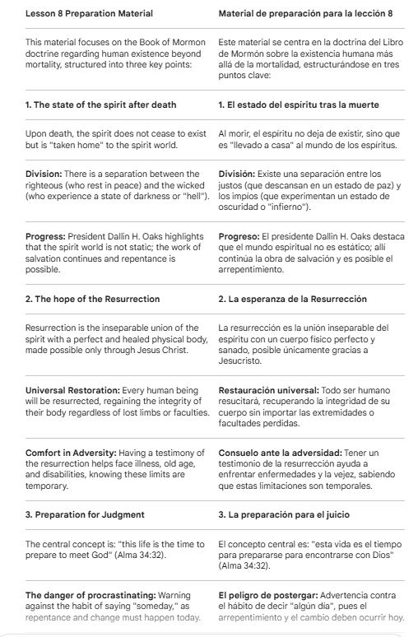

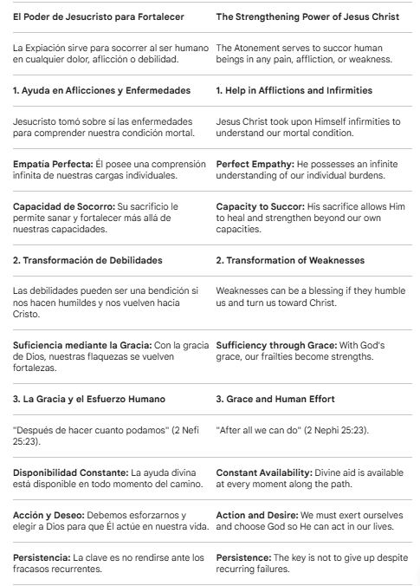

Prayer
Our Heavenly Father,
We give Thee thanks for the opportunity to gather as students and for the infinite gift of the Atonement of Thy Son, Jesus Christ. We are grateful for His perfect empathy and for His power to succor us in our physical, mental, and emotional afflictions.
We ask Thee to help us invite His strengthening power more fully into our lives. Please bless us with the humility to see our weaknesses as opportunities to turn to Him, and grant us Thy grace "after all we can do," so that our frailties may become strengths through His mercy. Help us to never give up and to keep striving with faith in His divine aid.
In the name of our Lord, Jesus Christ, Amen.

